**How to set up GitHub**

1. Sign up for a **GitHub** account at <https://github.com>.   
   A personal email is recommended here so you can keep it after graduation.

Note that your username will be in the URL of your website: yourusername.github.io.

1. Choose One team member and Student.
2. Choose the **free** plan.
3. Click **“Create Repository”**. (via the main page or the + menu at the top right)
4. Then, as shown the following picture, **make sure to name your repository exactly** “**YOUR_USERNAME.github.io**”. That tells Github that you’re making a webpage project. Since my username was "kwipaway", I named my project "kwipaway.github.io". Then, check “Public” and check to “Add a README file”. Then, click the Create repository button.

***Continue to the next page for how to work with VS Code 🡪***

**How to work with GitHub in VS Code**

1. You can use the Desktop version or online at: <https://vscode.dev/>
2. You can browse, search, edit, and commit to any remote GitHub repository directly from within VS Code.
3. Click “**Open Repository**” on the welcome page.
4. Then, click “**Open Repository from GitHub (remote sources)**” at the top drop-down box.

1. Then, click “**Allow**” to sign in using GitHub.

1. Click “**Open**” and then enter your GitHub username and password and click “**Sign in**”. Then, click “**Authorize**”.

1. Now, click your GitHub repository that pops up at the top box (e.g., **YOUR_USERNAME.github.io)**.
2. Now, you should see your GitHub repository on the left panel under the **Explorer icon** as shown in the picture below:

1. Now you can create a new file and/or a new folder (e.g., html, css) by hovering your mouse over your repository. Create a new file “**index.html**” and add the code as shown in the pictures below. Note that the index.html file is commonly the default page of a web site.



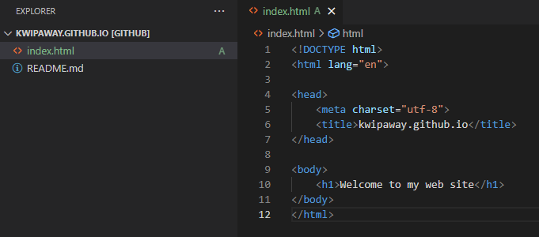

1. After you are finished adding the code, click the **Source Control icon** (third icon on the left shown with #1 right now as shown in the picture below). Then, you need to type a brief description such as “add index.html” (or even a character) in the description box. Then, click the √ button to commit the code to your repository.

1. Open your browser (Edge or Chrome) and type **YOUR_USERNAME.github.io** in the address bar. This will take to your index.html that you just committed in your repository. Congrats!! You just created your web site on GitHub!!

1. **Submit a screenshot like the one above on Bb and you can get extra credit (up to 3 points)!**